Mobile Game In-App Purchase Analysis

1. Introduction

The purpose of this project is to analyze player behavior and in-app purchasing patterns within a mobile gaming environment. The analysis uses two datasets: a player dataset containing demographic and gameplay information, and a purchase dataset containing transaction-level purchase records.
The objectives of the analysis are to:
* Understand player demographics and gameplay behavior.
* Analyze spending patterns and revenue generation.
* Identify factors associated with player purchases.
* Evaluate payment preferences and spending segments.
* Generate actionable recommendations for improving player engagement and monetization.
The analysis was performed using Python and Google Colab, with data exploration, statistical summaries, and visualizations used to identify key trends and insights.

2. Dataset Overview

The analysis was conducted using two datasets containing player information and purchase transactions from a mobile gaming platform.
Players Dataset
The players dataset contains 3,024 unique player records and 18 attributes describing demographic characteristics, gameplay behavior, and spending activity. Key variables include age, gender, country, device type, game genre, session activity, playtime, spending segment, and purchase-related metrics.
Purchases Dataset
The purchases dataset contains 2,887 transaction records and 10 attributes related to in-app purchases. These variables include purchase amount, purchase date, payment method, purchase segment, and days since installation.
Descriptive Statistics
Analysis of player activity revealed the following characteristics:
* Average player age: 33.53 years
* Average session count: 10.07 sessions
* Average session length: 20.07 minutes
* Average total playtime: 201.96 minutes
* Average in-app purchase amount: €97.97

The median in-app purchase amount was €11.46, while the maximum recorded purchase reached €4,964.45. The large gap between the median and maximum purchase values suggests the presence of a small group of high-spending players contributing substantially to overall revenue.

Player ages ranged from 13 to 54 years, indicating a diverse player base spanning teenagers to mature adult users.

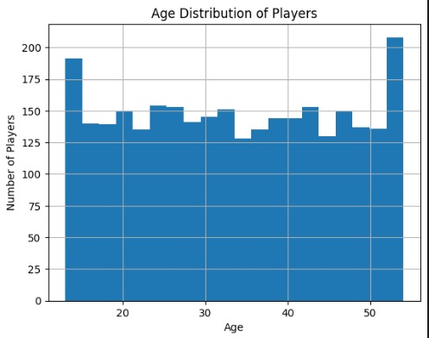

3. Data Quality Assessment
A data quality assessment was conducted to identify missing values and potential anomalies before performing detailed analysis.
Missing Values
The majority of variables contained complete information. However, a small number of missing values were identified in selected fields:

| Variable | Missing Values |
| --------------------------------- | -------------- |
| age | 60 |
| country | 60 |
| device | 60 |
| game_genre | 60 |
| first_purchase_days_after_install | 136 |
| payment_method | 136 |
| last_purchase_date | 136 |
| days_to_first_pay | 136 |
The missing demographic values represent approximately 2% of the player records and are unlikely to significantly affect overall analysis results.
Outlier Detection
The dataset contains an indicator variable named `is_outlier_age`. Analysis revealed that 60 records were flagged as age outliers. These records correspond directly to the 60 missing age values, suggesting that invalid or unrealistic ages were identified and removed during the data preparation process.

Data Reliability
The purchases dataset contained no missing values, indicating high-quality transaction data suitable for revenue and spending analysis. Overall, the datasets demonstrate good data quality and are appropriate for exploratory and business-focused analysis.
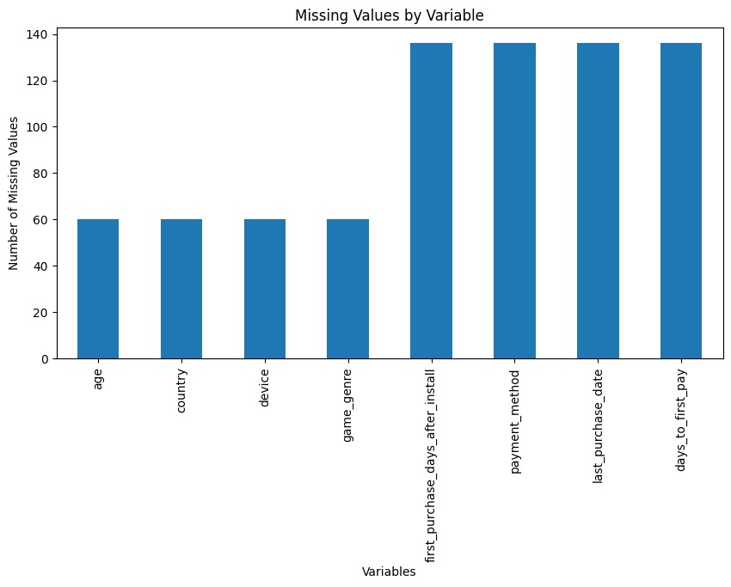

4. Player Demographics Analysis

Gender Distribution
The player base is predominantly male, with 1,810 players (approximately 60% of the dataset). Female players account for 1,098 records (approximately 36%), while a small proportion of players were categorized as Other (56) or Unknown (60).

The results indicate that the game attracts a largely male audience, although female participation remains substantial. This balanced representation provides opportunities for targeted engagement strategies across multiple player groups.

Country Distribution
The dataset contains players from multiple countries, demonstrating a geographically diverse user base.
The largest player population was observed in India, with 242 players. Other highly represented countries include Switzerland (119), Saudi Arabia (116), Mexico (115), Germany (114), Netherlands (114), Australia (113), Italy (112), Japan (112), and the United Kingdom (108).
The relatively even distribution among countries suggests that the game has achieved broad international reach rather than relying heavily on a single market.

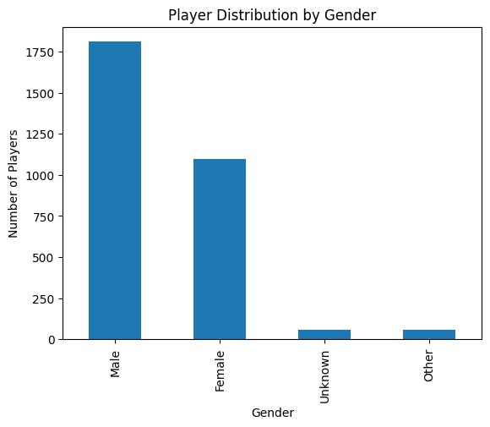
Figure 3: Distribution of players by gender. Male players represent the largest segment of the player base, followed by female players

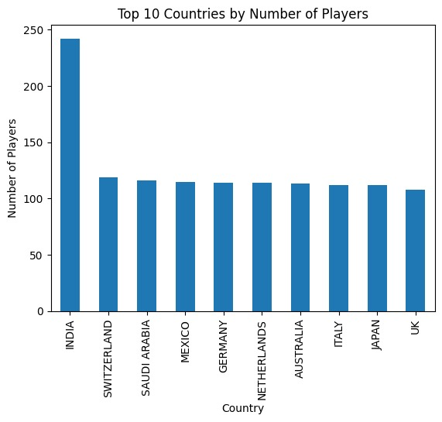

Figure 4: Top countries represented in the dataset. India contributes the largest number of players, followed by several European, Middle Eastern, and Asia-Pacific countries.

### Device Distribution

Analysis of device usage revealed that Android is the dominant platform among players. A total of 1,738 players used Android devices, while 1,226 players used iOS devices.

This indicates that approximately 59% of players access the game through Android devices, suggesting that Android should remain a primary platform for optimization, updates, and marketing efforts.

Game Genre Distribution
Player preferences were distributed across a wide variety of game genres. The most represented genres were Sandbox and Simulation, each with 219 players. Sports (217), Casual (209), Puzzle (206), and Card (202) games also demonstrated strong participation.
The relatively balanced distribution across genres suggests that the player base has diverse gaming interests and that no single genre overwhelmingly dominates user engagement.

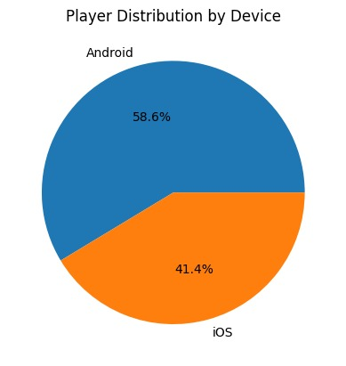

Figure 5: Distribution of players by device type. Android users represent the majority of the player base, accounting for approximately 59% of players.

F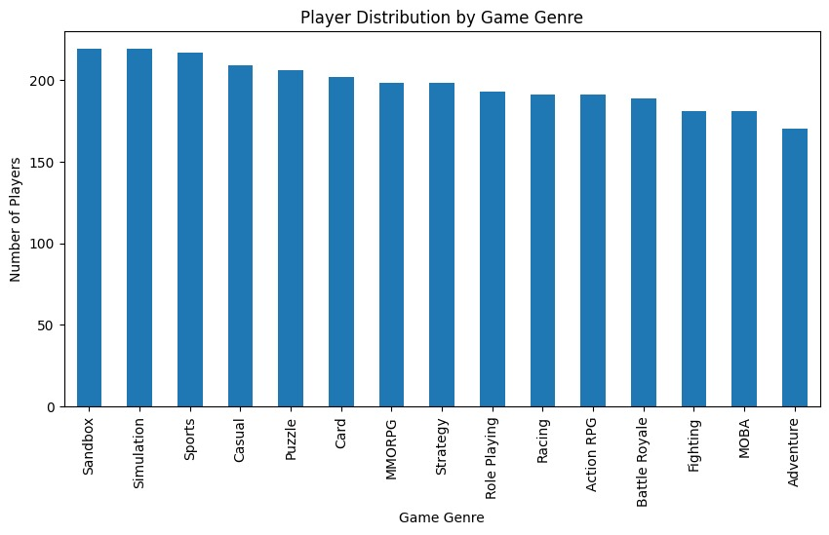

Figure 6: Distribution of players across game genres. Sandbox and Simulation genres recorded the highest player counts, although participation remained relatively balanced across genres.

5. Spending Behavior Analysis

Spending Segments
Players were categorized into three spending segments: Minnows, Dolphins, and Whales.
The majority of players belonged to the Minnow segment, with 2,544 players representing approximately 84% of the player base. Dolphins accounted for 412 players (approximately 14%), while only 68 players (approximately 2%) were classified as Whales.
This distribution is consistent with common mobile gaming monetization models, where a small number of high-spending users contribute a disproportionate share of total revenue.

Purchaser Conversion Analysis
Out of 3,024 total players, 2,887 players made at least one purchase, while 137 players did not make any purchases.
This corresponds to a purchaser conversion rate of approximately 95.5%, indicating exceptionally strong monetization performance. The high conversion rate suggests that the game's monetization systems are highly effective at encouraging players to make purchases.
Payment Method Analysis

Analysis of payment methods revealed that Debit Card transactions generated the highest revenue, contributing €55,909.54. PayPal (€48,349.50) and Gift Card purchases (€43,928.45) were also significant revenue sources.
Carrier Billing, Google Pay, Credit Card, and Apple Pay each generated substantial revenue, indicating that players actively use a variety of payment options.
The results suggest that maintaining multiple payment methods is important for maximizing revenue and reducing purchasing friction.

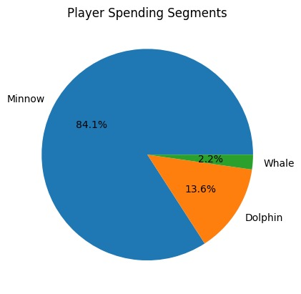
Figure 7: Distribution of players across spending segments. Minnows represent the majority of players, while Whales constitute a small but strategically important group.

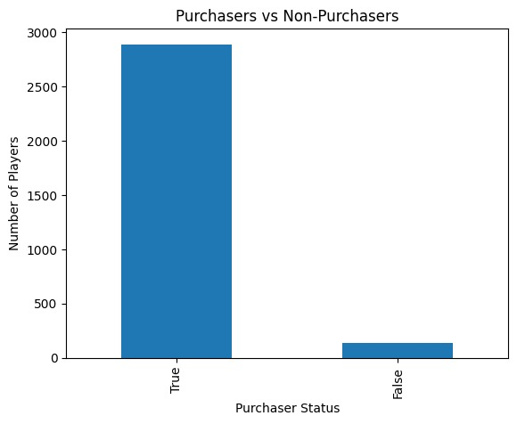
Figure 8: Comparison of purchasing and non-purchasing players. A large majority of players completed at least one transaction

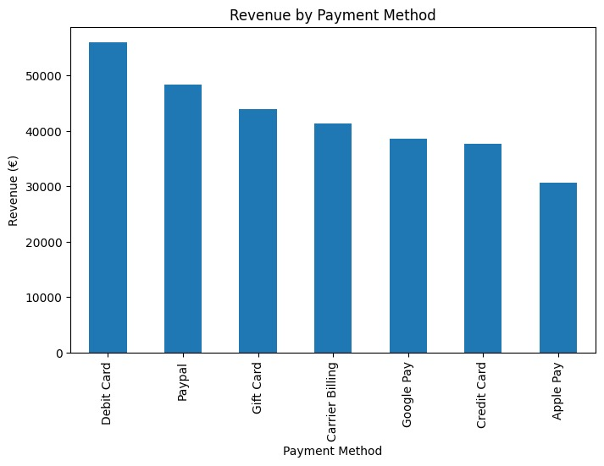
Figure 9: Revenue generated by each payment method. Debit Cards generated the highest revenue, followed by PayPal and Gift Cards.

6. Engagement Analysis
To investigate the relationship between gameplay activity and spending behavior, correlation analysis was performed using session count, average session length, total playtime, and in-app purchase amount.
Correlation Analysis
The results revealed a strong positive relationship between average session length and total playtime (correlation coefficient = 0.781). A moderate positive relationship was also observed between session count and total playtime (correlation coefficient = 0.565).
However, spending behavior showed almost no correlation with gameplay activity. The correlation between in-app purchase amount and total playtime was approximately 0.001, while the relationship between spending and session count was only 0.035.
These findings suggest that increased gameplay activity does not necessarily lead to higher spending. Players who spend large amounts of money are not always the players who spend the most time playing.
Spending Segment Comparison
Comparison of spending segments revealed significant differences in purchase behavior.
Whales generated an average in-app purchase amount of €2,582.11, compared with €233.71 for Dolphins and only €9.59 for Minnows.

Interestingly, gameplay metrics such as session count and total playtime remained relatively similar across all spending segments. This indicates that spending behavior is driven by factors beyond simple engagement, such as purchasing preferences, player motivation, or monetization design.

The findings highlight the importance of identifying and retaining high-value players, as a small group of Whales contributes substantially more revenue than the broader player population.

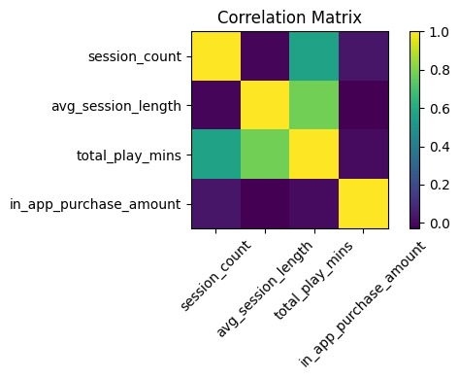

Figure 10: Correlation matrix showing relationships among gameplay activity and spending variables. Spending exhibits weak correlation with engagement metrics, while session activity and playtime are strongly related

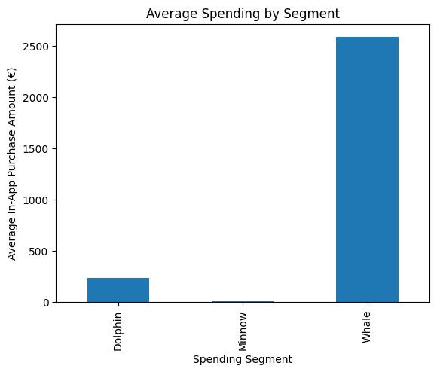

Figure 11: Average spending by player segment. Whales spend substantially more than Dolphins and Minnows despite exhibiting similar gameplay activity levels.

7. Key Findings

The analysis of player behavior and in-app purchase activity revealed several important insights:
1. The dataset contained 3,024 unique players and 2,887 purchase transactions, indicating a highly active player base.
2. Total in-app purchase revenue reached €296,259.31, with an average transaction value of €102.62.
3. The player base was predominantly male, accounting for approximately 60% of all players, while female players represented approximately 36%.
4. India contributed the largest number of players, followed by Switzerland, Saudi Arabia, Mexico, Germany, and the Netherlands, demonstrating strong international reach.
5. Android was the most commonly used platform, representing approximately 59% of players.
6. Sandbox and Simulation were the most represented game genres, although player participation was relatively balanced across all genres.
7. Minnows accounted for approximately 84% of players, while Whales represented only 2% of the player base. Despite their small numbers, Whales generated significantly higher spending levels.
8. The purchaser conversion rate exceeded 95%, indicating highly effective monetization performance.
9. Debit Cards generated the highest revenue among all payment methods, followed by PayPal and Gift Cards.
10. Gameplay engagement metrics such as playtime and session count showed very weak correlation with spending behavior, suggesting that high spending is influenced by factors other than simple gameplay activity.

8. Recommendations

Based on the findings of this analysis, the following recommendations are proposed:
1. Prioritize High-Value Players
Although Whales represent only a small proportion of the player base, they contribute substantially more revenue than other player segments. Special promotions, loyalty programs, and exclusive content should be considered to improve retention among these users.

2. Optimize the Android Experience

Since Android users represent the majority of players, maintaining strong performance and user experience on Android devices should remain a priority.
3. Continue Supporting Multiple Payment Methods

Revenue is distributed across several payment methods, indicating that players prefer different payment options. Maintaining diverse payment channels can help maximize conversion rates and reduce purchase friction. 4. Focus on Monetization Strategy Rather Than Playtime Alone

The analysis found little relationship between gameplay activity and spending. Increasing player playtime alone may not significantly improve revenue. Instead, monetization strategies should focus on player motivation, offer design, and personalized purchasing opportunities.
5. Expand International Market Strategies

The player base is geographically diverse, suggesting opportunities for localized promotions, language support, and region-specific events to improve engagement across different markets.
9. Conclusion
This project analyzed player demographics, gameplay activity, and in-app purchasing behavior using player and transaction datasets from a mobile gaming platform. The findings revealed a highly monetized player base with strong purchase conversion rates and substantial revenue generation.
The analysis showed that spending behavior varies considerably among player segments, with a small number of high-value users contributing disproportionately to overall revenue. Additionally, while gameplay activity is strongly associated with total playtime, it has limited influence on spending behavior.
Overall, the results provide valuable insights into player engagement, monetization performance, and revenue generation patterns. These findings can support future business decisions related to player retention, monetization strategy, payment systems, and market expansion.

